SPARK ON AWS

1. Install Amazon CLI using the below link:

http://docs.aws.amazon.com/ElasticMapReduce/latest/DeveloperGuide/emr-cli-install.html

2. Please execute the below commands to verify the installation

ruby -v
gem -v
./elastic-mapreduce - version

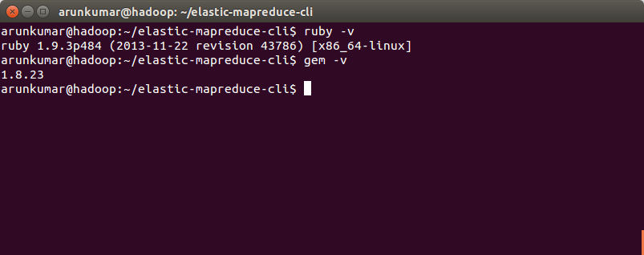
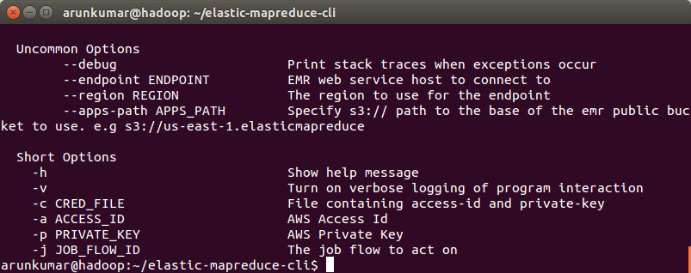

3. Run the below command to create a new spark cluster :

Note: The instance count determines the number of machines will be running in your cluster. Which can low as 1. Please use '1' initially as our sample programs will easily run in that. Also use 'expand all' option in bills to see your usage charges. If you are not using 'expand all' option, always it displays the bill as '0'.

elastic-mapreduce --create --alive --name "Spark/Shark Cluster" --bootstrap-action s3://elasticmapreduce/samples/spark/0.8.1/install-spark-shark.sh --bootstrap-name "Spark/Shark" --instance-type m1.xlarge --instance-count 1

This command will initiate a new cluster and you will see a message like :

Created job flow j-9HEOA4ORME0K

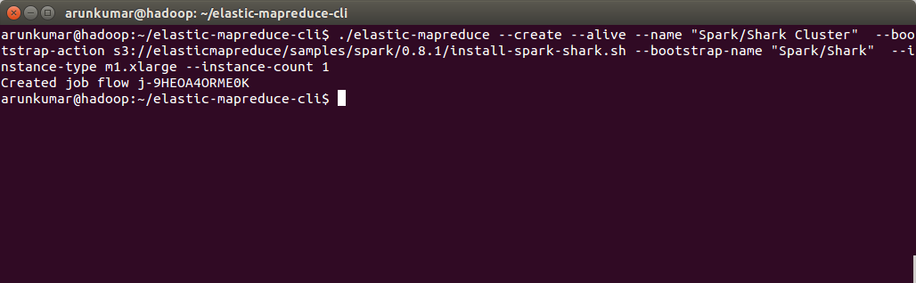

4. You can see the same cluster in AWS
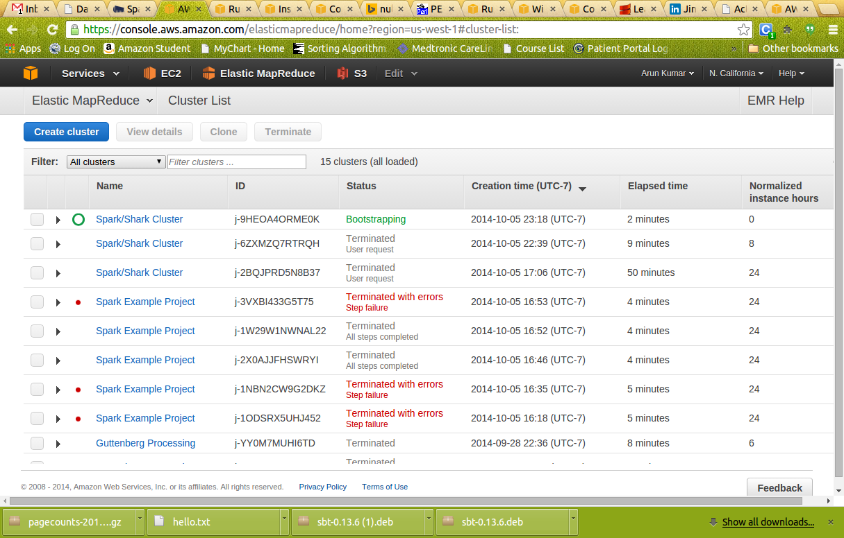

5. When your cluster is in the WAITING status, we will be using the sample data in one of the public S3 bucket located at the below link. We can directly use this data in our spark shell. So you dont have to download it.

https://s3.amazonaws.com/bigdatademo/sample/wiki/pagecounts-20100212-050000.gz.

6. Check the status of cluster. It should be in waiting state.
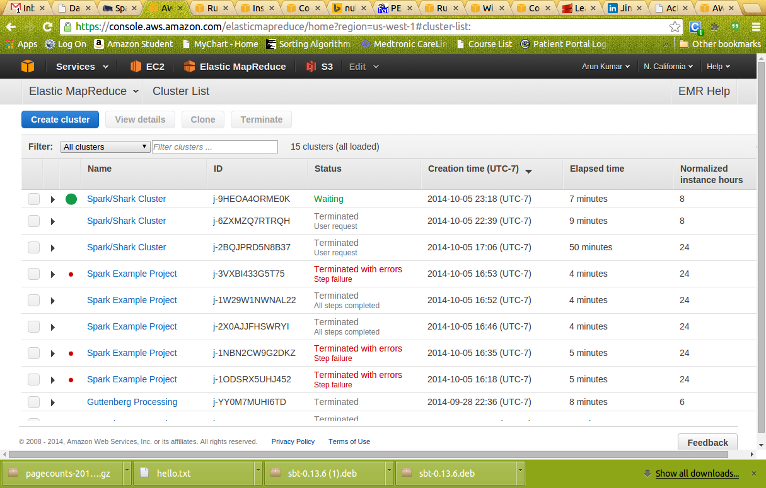

7.. Now we should ssh to master node to initialize spark shell. We will be running our scrips in master node. To get the ssh command, click on cluster, then 'cluster details' in Elastic Map reduce console page. Then click on SSH as shown below

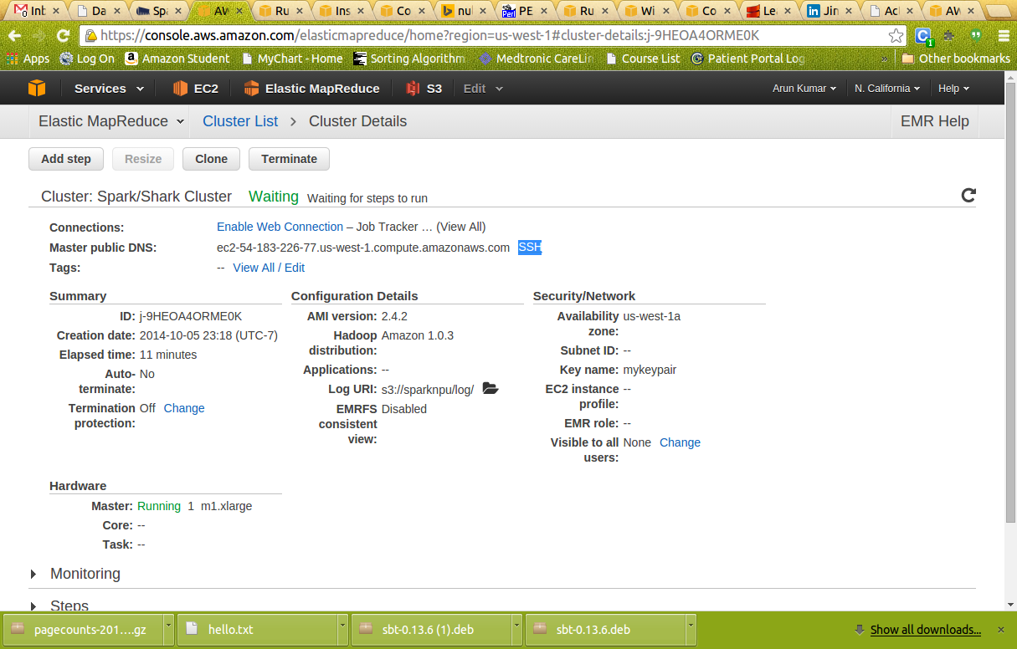

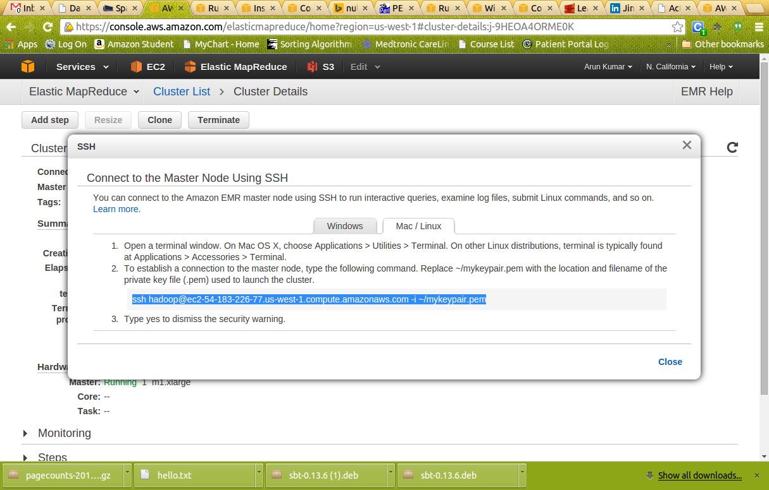

8. Copy the command as shown above. It should look like :

ssh hadoop@ec2-54-183-226-77.us-west-1.compute.amazonaws.com -i ~/mykeypair.pem

I hope your keypair is present in your home directory and the permission of the keypair file should be '600'. Other wise ssh will refuse to connect.

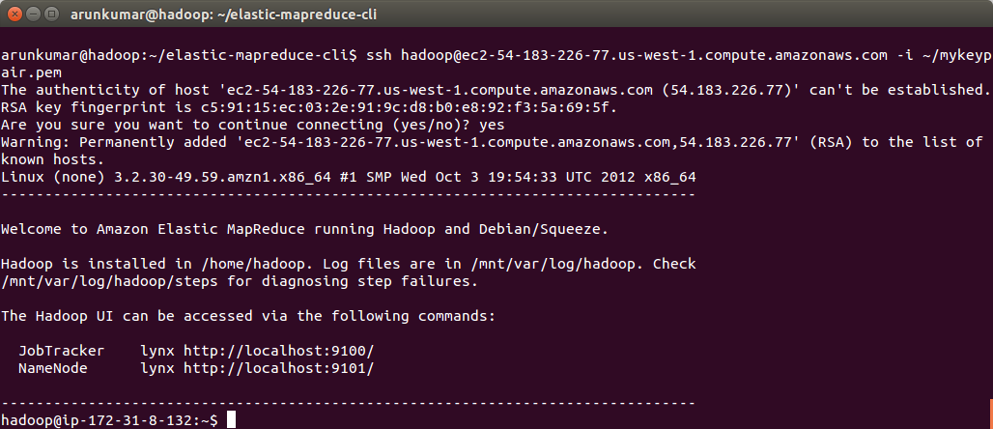

9. Open the spark shell

SPARK_MEM="2g" /home/hadoop/spark/spark-shell

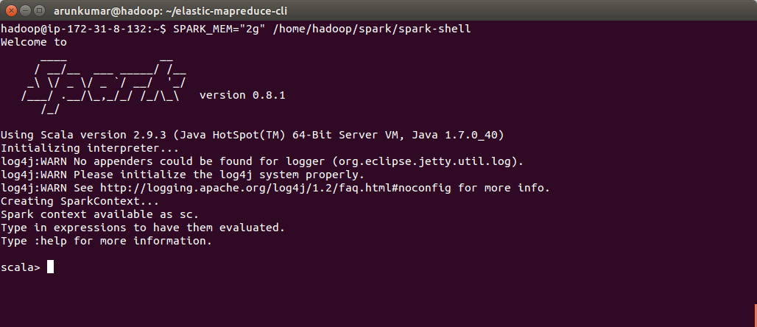
You will be treated with the scala prompt.

10. Run the below commands one by one.

val file = sc.textFile("s3://bigdatademo/sample/wiki/")

val reducedList = file.map(l => l.split(" ")).map(l => (l(1), l(2).toInt)).reduceByKey(_+_, 3)

reducedList.cache

val sortedList = reducedList.map(x => (x._2, x._1)).sortByKey(false).take(50)

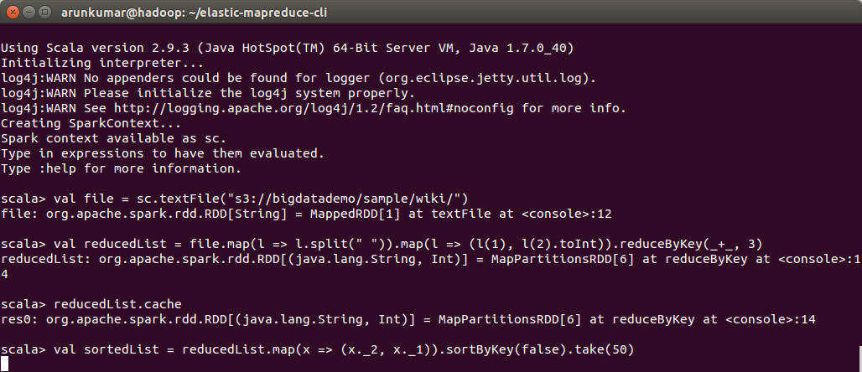

The first line tells Spark which file to process. In the second line we split each line of the dataset into multiple fields, taking the first and the second fields (page title and pageview count) and perform a groupBy based on the key (pagetitle). The third line caches the data in memory in case we need to re-run this job. This eliminates the need to read our dataset from Amazon S3 again. The last line sorts the list and provides the result.
As the cluster contains only 1 machine, it may take a while to process the input. The output should look like :

sortedList: Array[(Int, java.lang.String)] = Array((328476,Special:Search), (217924,Main_Page), (73900,Special:Random), (65047,404_error/),(55814,%E3%83%A1%E3%82%A4%E3%83%B3%E3%83%9A%E3%83%BC%E3%82%B8), (21521,Special:Export/Where_Is_My_Mind), (19722,Wikipedia:Portada),(18312,%E7%89%B9%E5%88%A5:%E6%A4%9C%E7%B4%A2), (17080,Pagina_principale)

Note: For faster processing, please create cluster with minimum 3 machines.

11.Clean up.

a. Disconnect from the master node by terminating your SSH session.
b. Then execute the below command with your job id.

elastic-mapreduce --terminate -j j-367J67T8QGKAD
(Job id of your job)
or

clicking 'terminate' in the cluster.

Very important : Please terminate the cluster. Otherwise AWS charges can go high as 100$ in a week time!

